Project Lima Manual

Our project is a turn based, 2-player Northwestern themed card game that has peer-to-peer capabilities. Please read the introduction below about the rules of game.

### Objective

Decrease the other player’s health points from total to zero by efficiently playing cards.

### Player

* Health – At the beginning of game, each player has a Health of 50 credits. When the credits reduce to 0, the player loses the game.
* Wildcat Points [WP]: WP is the resource to place cards on board. If WP is less than the cost of the card, the card cannot be placed onto the board. Each turn, a player gets 5 WPs.
* Deck - Each player has a deck of 30 cards that is a subset of standard 50-card deck.

### Card



There are two types of cards, regular cards and ability cards. Every card has a name, image and WP cost. Cards with just these three attributes are ability cards, and interact with the board upon begin played but do not stay on the board. In other words they perform an action once and then are discarded.

Most of the cards in the game are regular cards. Regular cards have two additional elements, attack and defense. These cards, when played, will become members of the board. Once on the board, a regular card can attack one of the opponent’s regular cards each turn, beginning with the turn it is played.

### Playing the Game

Connect: Before playing the game, the two players’ computer should connect with each other. First, the server must be initiated. One player should input the other’s IP address to connect. After connecting, player can create a new game.

The game board interface is split in half, one side for each player. Each player can see their own hand and the cards that are on the board, as well as important information about each player.

During a players’ turn: Each turn, a player has 5 WP to play per turn. A player must decide which cards to play based on their WP cost values. If the player has any cards on the board, they must make a decision on how to use them, either on the opposing player or the players’ cards.

Some cards have abilities that require you to select a specific card as a target. To use such an ability, right click on the desired target *immediately* after playing the card and click “Use ability on.” This is important for ability cards with 1 target: they will disappear upon being played, but the ability will not be activated unless a target is chosen.

When one card attacks another, each card involved loses an amount of health equal to the opposing card’s attack value. If either card’s health is reduced to zero or less, that card is removed from the board.

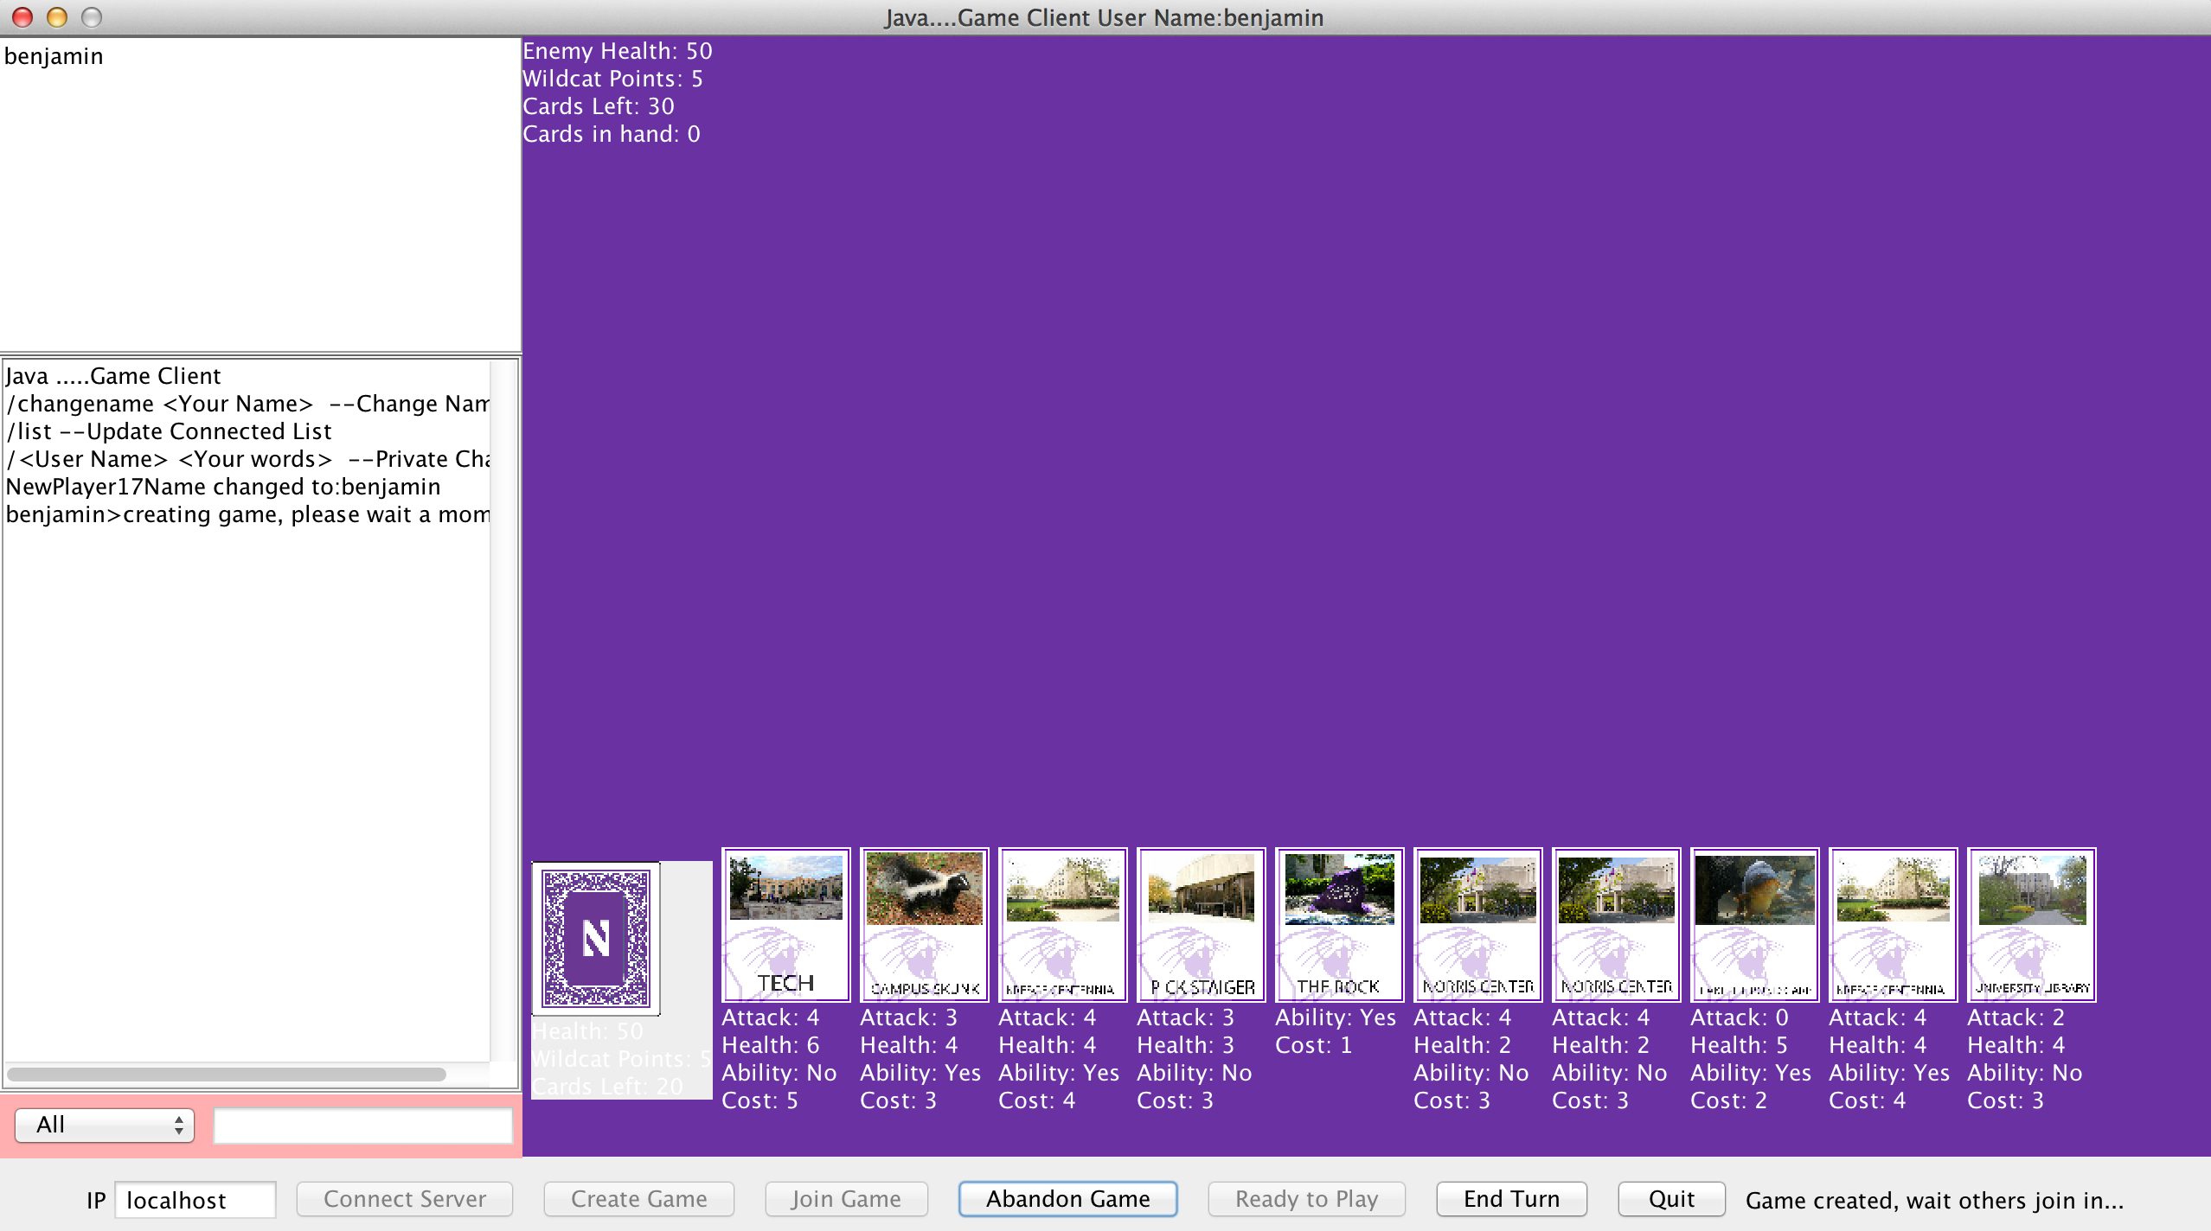

What the board looks like as a game is created by the userPlayer

### Using the Application

#### Start a new game:

For server side:

1. Open LimaServer.jar
2. Open the client by opening Project_Lima.jar
3. Enter a name
4. If applicable, In the textfield with “localhost” change “localhost” to the server’s IP address
5. Click the “Connect Server” button
6. Click the “Create Game” button, building the game will take a few moments. (30 seconds on a fast internet connection)
7. Wait for another player to join

For client side:

1. (For another player) Open another client by opening Project_Lima.jar again and repeat steps 3-5 above
2. Click on the player name you chose before from the top left hand textfield.
3. Click the join game button, this will take a few moments
4. After both players receive the message stating that both players have joined, click the ready to play button
5. The player who created the game can now start his turn.
6. Players end turns by clicking on the “End Turn” button

#### During the game:

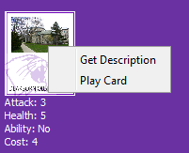 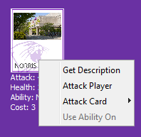

To play a card To attack a player or Card

* When you want to see the description of a card, right click the card, or control-click on Mac, to see its description.
* When you want to play a card, right click the card, or control-click on Mac, to see the menu. Click “play card“ to play a card.
* When you want to attack a card, right click the card, or control-click on Mac, on which card is played, and click “Attack player” to attack player, or click “Attack Card ” to choose which card you want to attack.